CAP-app

Enhanced Conservation Action Planning Software
CAP-app is a completely new CAP Excel Workbook designed for strategic conservation planning. Developed by Greg Low, CAP-app has been used with the Tanana Valley Watershed Association and partners to develop a Watershed Resource Action Plan (WRAP) for the Chena River Watershed in Alaska.
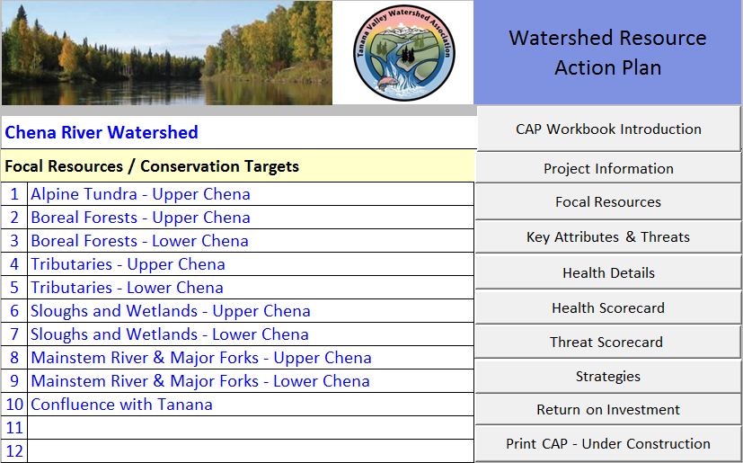

What’s Different about CAP-app
- Shows the current and projected future health (aka viability) of each target with and without strategic action.
- Measures target health on a scale of 0 (poor) to 100 (very good), allowing teams to more easily assess condition, compare results, and assess strategic benefits.
- Provides a simpler and arguably more robust threat ranking approach, based upon projected degradation of Key Ecological Attributes (KEAs).
- Ranks targets & KEAs most needing attention based on current condition plus future threat.
- Assesses the return on investment (ROI) of pursuing alternative strategic objectives.
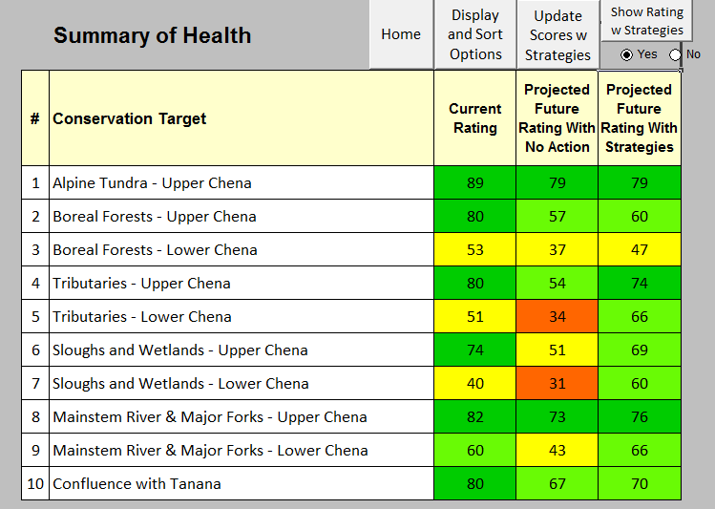
Health Scorecards -- With and Without Strategic Action
- Current Health scores for each target are presented on a scale of 0 to 100, based upon a weighted average of the KEA ratings for the target.
- Future Health With No Action reflects the projected Health scores in 10 years based upon expected threats and circumstances.
- Future Health with Strategic Actions reflects the projected scores if selected strategic objectives are successfully implemented, and provides a vital comparison.
Threats are assessed by directly projecting the future KEA ratings assuming continuation of current circumstances, management and policies. The former Stress Ranking procedure (which pre-dated KEAs) is thereby eliminated, and greater accuracy is brought to threat ratings.
- Ratings of “Good – “ and “Fair – “ have been added to for KEAs, to reflect the often wide ranges in these categories, and the fact that conditions often trend down within a category.
- Sources are still graded by their Contribution -- to degraded KEAs. However, the confusing Irreversibility ratings have been discontinued, based upon an analysis that showed they made little difference to the final Threat scorecard.
- The Overall Threat Scorecard remains essentially the same as the CAP Excel Workbook.
ROI shows which strategic objectives yield the most benefit towards improving target health (KEAs) considering feasibility and cost – in comparison to Future Health with No Action.
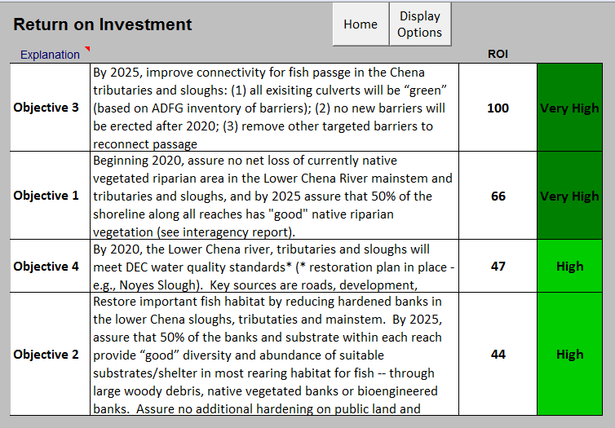

What’s the Same
CAP-app still uses the longstanding core approach to developing a Conservation Action Plan – selecting focal resources (conservation targets); determining and rating the key attributes of the targets’ health; assessing what is likely to get worse and why; developing measurable objectives to enhance future health and/or abate threats; and developing strategic actions to achieve these objectives. Key Ecological Attributes (KEA) are the vital foundation and “currency” of CAP-app – everything is built upon them, leading up to measurable strategic outcomes.

What’s Next
CAP Coaches are invited to try out and use the software. Anyone familiar with the CAP Excel Workbook should be able to navigate through the process. CAP-app requires Excel software on a Windows-based computer or tablet; since it is programmed in Visual Basic, it requires macros be enabled. Greg hopes eventually to migrate CAP-app to a web-based, interview-driven platform. It can be downloaded at appliedconservation.com. Feedback is welcomed and encouraged. Contact Greg Low at glow@appliedconservation.com

